Github::
https://github.com/Manjunath-Kapanaiah/fraud-detection_Task3.git
Gitlab::
https://gitlab.com/Manjunath-Kapanaiah/user-auth-service.git

📘 End-to-End CI/CD Multi-Project Dependency Chain

Fraud Detection System – DevOps Project Report

🔷 1. Project Overview
This project demonstrates a real-world CI/CD pipeline orchestration involving:
- GitLab → User Authentication Service
- Jenkins → Orchestration Engine
- Kubernetes (Minikube) → Deployment Platform
- GitHub Actions → Transaction Service
- Rollback & Notifications → Failure handling

🎯 2. Objective
To build a multi-system dependency chain pipeline where:
- GitLab pipeline triggers Jenkins
- Jenkins waits for GitLab success
- Jenkins deploys Fraud Detection service
- Jenkins triggers GitHub Actions
- Jenkins waits for GitHub success
- On failure → rollback + alert

🏗️ 3. Architecture Flow
GitLab (User Auth)
↓
Jenkins Pipeline
↓
Kubernetes Deployment
↓
GitHub Actions (Transaction)
↓
Success / Failure
↓
Rollback + Notification

📁 4. Project Directory Structure

🔹 GitHub Repo (fraud-detection_Task3)
fraud-detection_Task3/
│
├── Jenkinsfile
├── fraud-deployment.yaml
│
└── .github/
└── workflows/
└── deploy.yml

🔹 GitLab Repo (user-auth-service)
user-auth-service/
│
└── .gitlab-ci.yml

⚙️ 5. Tools & Technologies
Tool | Purpose
Jenkins | CI/CD Orchestration
GitLab | Upstream trigger
GitHub | Downstream workflow
Minikube | Kubernetes cluster
kubectl | Deployment tool
curl | API communication
jq | JSON parsing

🔐 6. Credentials Configuration
Configured in Jenkins:
- gitlab-token
- github-token
- kubeconfig (optional)

📜 7. Code Implementation

🔹 GitLab CI Pipeline
stages:
- build
- trigger

build_job:
stage: build
script:
- echo "Building User Auth Service"

trigger_jenkins:
stage: trigger
script:
- curl -X POST --user admin:<API_TOKEN> "http://<JENKINS_IP>:8080/job/fraud-detection/build?token=fraud123"

🔹 GitHub Actions Workflow
name: Transaction Deployment

on:
workflow_dispatch:

jobs:
deploy:
runs-on: ubuntu-latest

steps:
- uses: actions/checkout@v3

- name: Simulate Deployment
run: |
echo "Deploying Transaction Service"
sleep 10

🔹 Kubernetes Deployment File
apiVersion: apps/v1
kind: Deployment
metadata:
name: fraud-detection
spec:
replicas: 1
selector:
matchLabels:
app: fraud
template:
metadata:
labels:
app: fraud
spec:
containers:
- name: fraud-container
image: nginx
ports:
- containerPort: 80

🔹 Final Jenkins Pipeline
pipeline {
agent { label 'JENKINS-2' }

environment {
GITLAB_TOKEN = credentials('gitlab-token')
GITHUB_TOKEN = credentials('github-token')
GITLAB_PROJECT_ID = '<PROJECT_ID>'
}

stages {

stage('Checkout Code') {
steps {
git branch: 'main',
url: 'https://github.com/Manjunath-Kapanaiah/fraud-detection_Task3.git'
}
}

stage('Check GitLab Pipeline Status') {
steps {
script {
timeout(time: 5, unit: 'MINUTES') {
waitUntil {
def response = sh(
script: """
curl --silent --header "PRIVATE-TOKEN: ${GITLAB_TOKEN}" \
https://gitlab.com/api/v4/projects/${GITLAB_PROJECT_ID}/pipelines?per_page=1
""",
returnStdout: true
).trim()

return response.contains('"status":"success"')
}
}
}
}
}

stage('Verify Kubernetes') {
steps {
sh 'kubectl get nodes'
}
}

stage('Deploy') {
steps {
sh 'kubectl apply -f fraud-deployment.yaml'
}
}

stage('Trigger GitHub') {
steps {
sh """
curl -X POST \
-H "Authorization: Bearer ${GITHUB_TOKEN}" \
https://api.github.com/repos/Manjunath-Kapanaiah/fraud-detection_Task3/actions/workflows/deploy.yml/dispatches \
-d '{"ref":"main"}'
"""
}
}

stage('Wait for GitHub Success') {
steps {
script {
timeout(time: 5, unit: 'MINUTES') {
waitUntil {
def result = sh(
script: """
curl --silent \
-H "Authorization: Bearer ${GITHUB_TOKEN}" \
https://api.github.com/repos/Manjunath-Kapanaiah/fraud-detection_Task3/actions/runs \
| jq -r '.workflow_runs[0].conclusion'
""",
returnStdout: true
).trim()

return result == "success"
}
}
}
}
}
}

post {
failure {
echo "Rollback triggered"
sh 'kubectl rollout undo deployment/fraud-detection'
}

success {
echo "Pipeline successful"
}
}
}

❌ 8. Failures Faced & Fixes

🔴 Issue 1: GitLab Pipeline Invalid
Error:
stage does not exist
Fix:
- Defined stages explicitly:
stages:
- build
- trigger

🔴 Issue 2: Jenkins Trigger 403 (Crumb Error)
Fix:
- Used API token authentication:
curl --user admin:API_TOKEN

🔴 Issue 3: Jenkins Branch Error
Error:
couldn't find remote ref master
Fix:
- Changed branch to:
main

🔴 Issue 4: No Executors
Fix:
- Set executors = 1 in node configuration

🔴 Issue 5: Agent Offline
Fix:
- Fixed SSH known_hosts
- Connected agent properly

🔴 Issue 6: kubectl Not Found
Fix:
sudo snap install kubectl --classic

🔴 Issue 7: kubeconfig Missing
Fix:
- Installed Minikube
- Started cluster
minikube start --driver=docker

🔴 Issue 8: Deployment File Missing
Fix:
- Created fraud-deployment.yaml

🔴 Issue 9: Jenkins DSL Error
Error:
No such DSL method 'steps'
Fix:
- Removed steps {} from post

🔁 9. Rollback Strategy
If GitHub workflow fails:
kubectl rollout undo deployment/fraud-detection

📢 10. Notification Strategy
- GitHub Issue creation (optional)
- Console logs

✅ 11. Final Outcome
✔ Fully working CI/CD pipeline
✔ Multi-platform integration
✔ Automated deployment
✔ Failure handling with rollback
✔ Real-world DevOps scenario implemented

🧠 12. Key Learnings
- Cross-platform CI/CD orchestration
- API-based pipeline triggering
- Kubernetes deployment handling
- Debugging real pipeline failures
- Secure credential management

🎯 13. Conclusion
This project successfully demonstrates a production-style DevOps pipeline integrating multiple tools with:
- Dependency handling
- Automated deployment
- Failure recovery
- Scalable architecture

🚀 14. Interview Summary (Use This)
“I implemented an end-to-end CI/CD pipeline integrating GitLab, Jenkins, Kubernetes, and GitHub Actions with dependency checks, automated deployment, rollback strategy, and failure notifications.”

Project Report: Fraud Detection Pipeline with Jenkins CI/CD

1. Project Overview
Objective:
Design an automated fraud detection pipeline that validates transactions, triggers alerts, and ensures rollback on failures using Jenkins CI/CD. The pipeline integrates Git for version control, uses agents for distributed builds, and handles real-time validation for high-throughput data.
Key Features:
- Automated build and deployment pipeline using Jenkins
- Git-based version control with hotfix & feature branching
- Failure simulation & rollback strategy
- Distributed agent setup for parallel execution
- Logging, monitoring, and alerting for validation failures
- Parameterized jobs for flexible execution

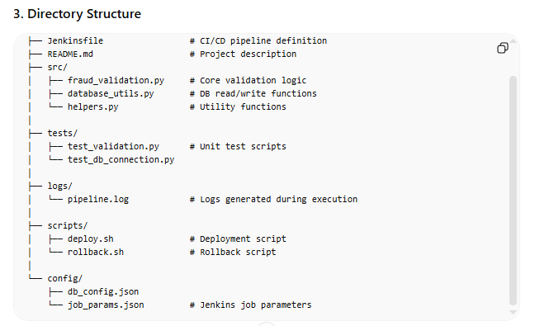

4. Key Steps
- Git Workflow:
  - Clone repository: git clone git@github.com:Manjunath-Kapanaiah/Fraud-Detection.git
  - Feature branch: git checkout -b feature/validation
  - Hotfix branch for production issues: git checkout -b hotfix/SEC-2023-001 production
- Jenkins Pipeline Setup:
  - Parameterized Jenkins job for branch selection
  - Define stages in Jenkinsfile:
    - Checkout
    - Build
    - Unit Testing
    - Integration Testing
    - Deployment
    - Rollback (on failure)
  - Distributed execution on multiple agents for scalability
- Failure Simulation & Rollback:
  - Introduce errors in test scripts: assert False to simulate failures
  - Use Jenkins post-action for rollback:
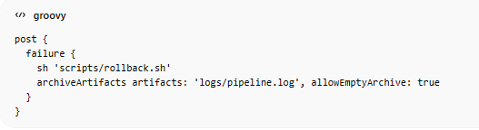
Monitoring & Logs:
- Logs saved in /logs/pipeline.log
- Alerts for failures via email or Slack (if integrated)
- Continuous monitoring ensures timely rollback and minimal disruption

5. Sample Jenkinsfile (Simplified)
pipeline {
agent any
parameters {
string(name: 'BRANCH_NAME', defaultValue: 'main', description: 'Git branch to build')
}
stages {
stage('Checkout') {
steps {
git branch: "${params.BRANCH_NAME}", url: 'git@github.com:Manjunath-Kapanaiah/Fraud-Detection.git'
}
}
stage('Build') {
steps {
sh 'echo "Building the project..."'
}
}
stage('Unit Test') {
steps {
sh 'pytest tests/test_validation.py'
}
}
stage('Integration Test') {
steps {
sh 'pytest tests/test_db_connection.py'
}
}
stage('Deploy') {
steps {
sh 'bash scripts/deploy.sh'
}
}
}
post {
failure {
echo 'Pipeline failed! Triggering rollback...'
sh 'bash scripts/rollback.sh'
archiveArtifacts artifacts: 'logs/pipeline.log', allowEmptyArchive: true
}
}
}

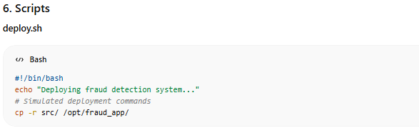

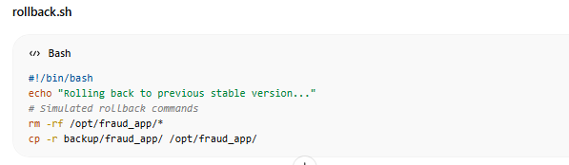

7. Explanation of Key Components
- Jenkinsfile: Automates build, test, deploy, and rollback.
- Agents: Distributed execution allows parallelization.
- Scripts: Deploy & rollback ensure safe recovery.
- Logs: Centralized logging for monitoring and audit.
- Git Workflow: Supports feature branching, hotfixes, and production safety.
Impact:
- Reduced manual intervention
- Real-time fraud detection
- Minimized downtime with automated rollback
- Clear audit trail for troubleshooting

